# CIMS QUEUES AND TASKS ACTIVITIES FOR INTEGRATION

* Suspend current Queues for HS Pick Creation and HS Despatch Creation
* Create new Queue for HS 1 2 1 Despatch and Pick Creation
* Create new Queue for HS Order Status and Order Payment Update
* Create Task for HS Order Status for UK and US Orders
* Create Task for HS Order Payment Status

Contents

CIMS QUEUES AND TASKS ACTIVITIES FOR INTEGRATION 1

Prerequisite to modify CIMS JOB Queues and Tasks 2

QUEUE AND TASK CREATION 2

HS MULE ORDER PAYMENT STATUS 4

HS MULE ORDER STATUS UPDATE 6

HS MULE PAYMENT STATUS 9

Current HS Pick and Despatch Create Queues for 1 to 1 Picks configuration. 11

Examples of HS Pick creation parameters for creating the task jobs in the HS Picks Creation Queue. 13

# Prerequisite to modify CIMS JOB Queues and Tasks

To create and modify Queues and Tasks a user requires the DBA role within CIMS

F11 allows you to query a Queue/Task

F12 actions the query.

% is a wildcard character when querying a Queue.

# QUEUE AND TASK CREATION

Brief steps to create a Queue and then a Task which runs in the queue

1. Create a Queue first -  click Q, Click  + then fill in the details of the Queue, then Click  Save icon to save the Queue record.
2. Having created the Queue, Click the Task tab, then place cursor in the Name and click  +, next type the new Task name, then click in the Name field  in the 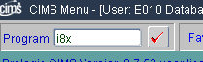 type the program to run in the task. This will bring up the programs screen. Select the parameters and click OK or Apply. The program should appear in the Task list, click Save icon to save the Task
3. Having created the Task it needs adding to the Queue. Click the Tab Queue and click the Cursor in to Name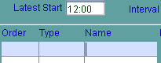 then Click + which will show a list of task to choose, 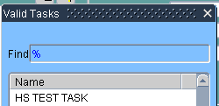 select the task then click , then repeat if more tasks are to be added.

# HS MULE ORDER PAYMENT STATUS

This queue runs 2 tasks to update HS Order status and HS Order payments

TASKS

HS MULE ORDER STATUS UPDATE runs program i8x to update UK and US orders delivery status

HS MULE PAYMENT STATUS runs program i8x to update UK and US order payment status

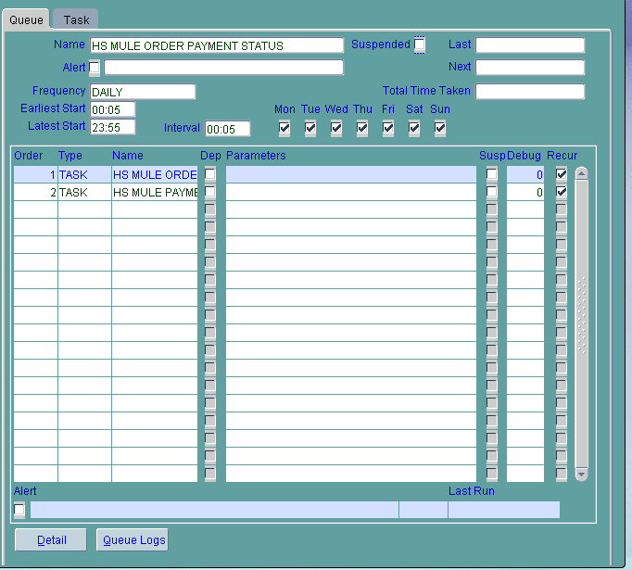

## HS MULE ORDER STATUS UPDATE

This task runs program i8x twice to update UK and US separately, using the following parameters respectively

'Y' 'MSTAUK' 'B'

'Y' 'MSTAUS' 'B'

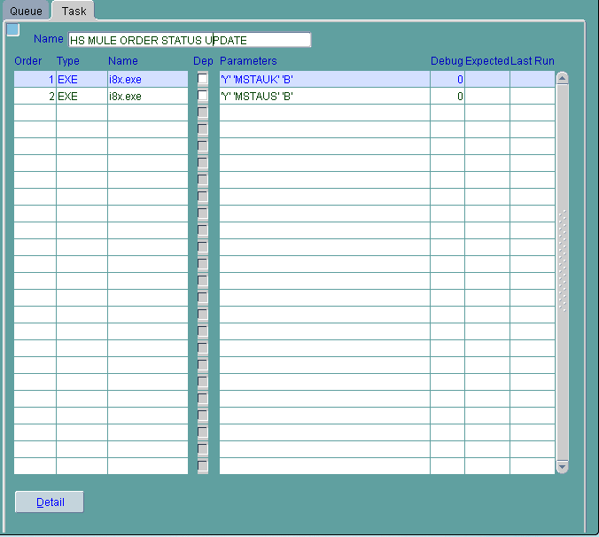

Program i8x

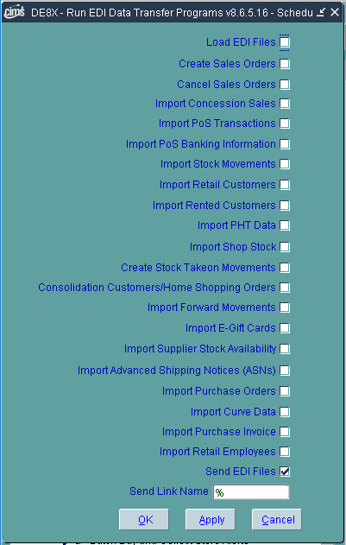

## HS MULE PAYMENT STATUS

This task runs program i8x once to update Order payment status, using the following parameters

'Y' 'MULPAY' 'B'

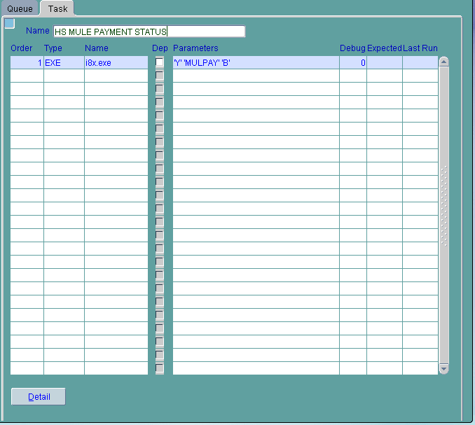

# Current HS Pick and Despatch Create Queues for 1 to 1 Picks configuration.

Current

|  |  |  |
| --- | --- | --- |
| Queue Name | Program | Parameters |
| HS PICK CREATION – Every 5mins | /procims/cbinl/l0f-1.exe |  |
|  | /procims/cbinl/l0f-2.exe |  |
|  | /procims/cbinl/l0c-1.exe | '90004' 'GAR-CUST-STOCK' '0' '%' '%' '%' '%' '%' '%' '0' '9' '3 ROAD 1' 'HS' '11-SEP-2017' |
|  | /procims/cbinl/l0c-1.exe | '90004' 'GAR-CUST-STOCK' '0' '%' '%' '%' '%' '%' '%' '0' '9' '%' 'HS' '18-SEP-2017' |
|  | /procims/cbinp/p0c-1.exe | 'GAR-CUST-STOCK' '90004' '%' 'W' '%' '14-AUG-2017' '19-SEP-2030' '%' 'HS' '%' '%' '%' '%' '%' '%' '%' '%' '%' '%' '%' '%' '%' 'H' 'F10474' '99' 'lp4' '1' 'Y' '999' '0' '9' 'N' '19-SEP-2030' 'Y' 'I' 'Y' 'N' 'I' 'I' 'N' 'Y' |

NEW

|  |  |  |
| --- | --- | --- |
| Queue Name | Program | Parameters |
| HS CREATE PICKS 1 TO 1 | /procims/cbinp/p0c-1.exe | 'GAR-CUST-STOCK' '90004' '%' 'W' 'M' '03-JAN-2018' '31-JAN-2028' '%' '%' '%' '%' '%' '%' '%' '%' '%' '%' '%' '%' '%' '%' '%' 'H' 'F30350' '99' 'lp4' '1' 'Y' '999' '0' '9' 'N' '31-JAN-2028' 'Y' 'I' 'Y' 'N' 'I' 'I' 'N' 'Y' |
|  | /procims/cbinp/p0c-1.exe | 'GAR-CUST-STOCK' '90004' '%' 'W' 'E' '03-JAN-2018' '31-JAN-2028' '%' '%' '%' '%' '%' '%' '%' '%' '%' '%' '%' '%' '%' '%' '%' 'H' 'F30350' '99' 'lp4' '1' 'Y' '999' '0' '9' 'N' '31-JAN-2028' 'Y' 'I' 'Y' 'N' 'I' 'I' 'N' 'Y' |
|  | /procims/cbinp/p0c-1.exe | 'RETAIL-STOCK' '90003' '%' 'R' '%' '12-FEB-2018' '12-MAR-2028' '%' '%' '%' '%' '%' '%' '%' '%' '%' '%' '%' '%' '%' '%' '%' 'H' 'F30350' '99' 'lp4' '1' 'Y' '999' '0' '9' 'N' '' 'N' 'I' 'Y' 'N' 'I' 'I' 'N' 'Y' |
|  | /procims/cbinp/p0f-1.exe | '%' '%' 'Y' '%' '%' '%' '%' '%' 'PREP' 'PICK' 'Y' 'Y' '1' 'lppdf' '1' 'R' |
|  |  |  |

Changes

1. Create a New Queue HS CREATE PICKS 1 TO 1
2. Create 2 new tasks A. CREATE HS PICKS 1 TO 1

B. CREATE PICKS

1. Need to set One to One as ticked
2. Need to tasks for Despatch State Mail Order and Ecommerce

Examples of the New Queue and tasks

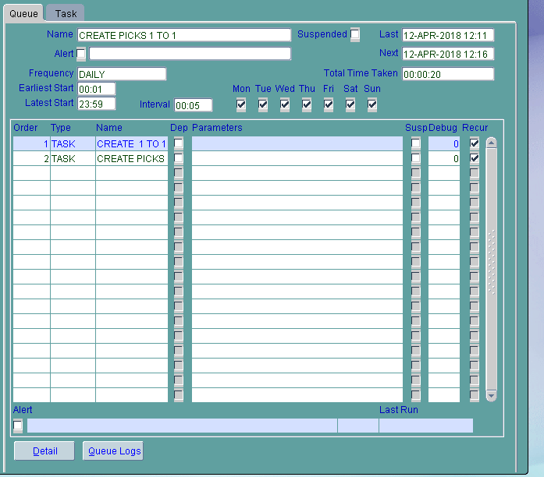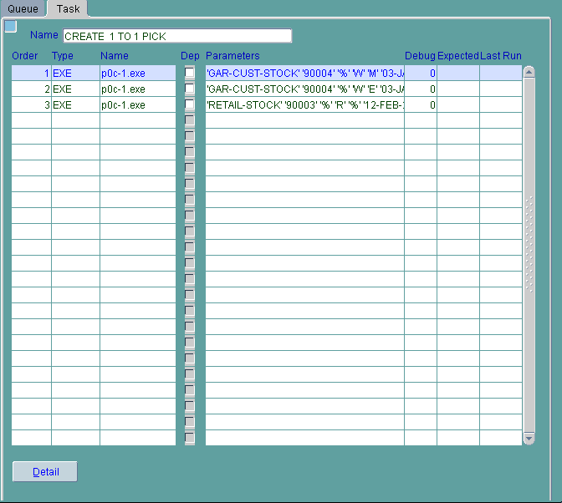 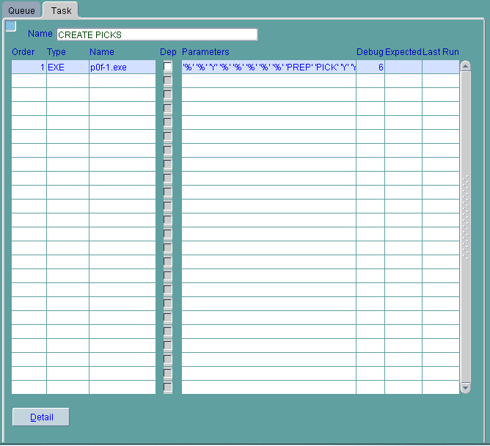

Examples of HS Pick creation parameters for creating the task jobs in the HS Picks Creation Queue.

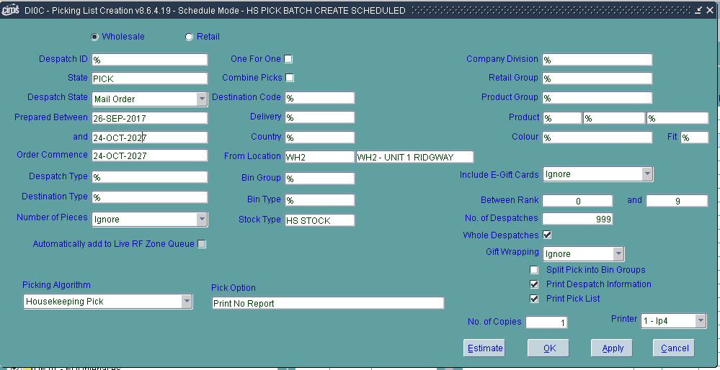

'GAR-CUST-STOCK' '90004' '%' 'W' 'M' '26-SEP-2017' '24-OCT-2027' '%' '%' '%' '%' '%' '%' '%' '%' '%' '%' '%' '%' '%' '%' '%' 'H' 'E010' '99' 'lp4' '1' 'Y' '999' '0' '9' 'N' '24-OCT-2027' 'N' 'I' 'Y' 'N' 'I' 'I' 'N' 'Y'

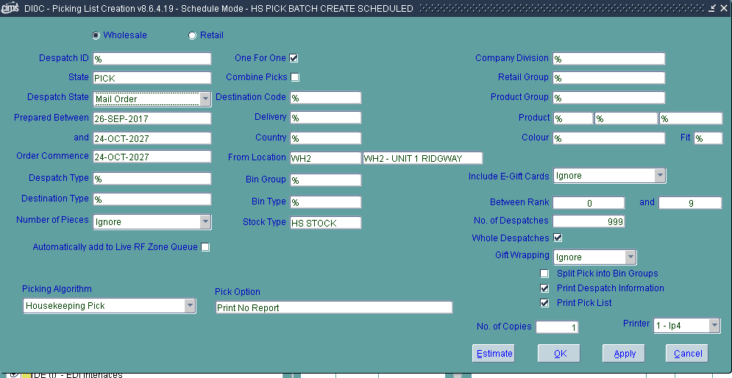

'GAR-CUST-STOCK' '90004' '%' 'W' 'M' '26-SEP-2017' '24-OCT-2027' '%' '%' '%' '%' '%' '%' '%' '%' '%' '%' '%' '%' '%' '%' '%' 'H' 'E010' '99' 'lp4' '1' 'Y' '999' '0' '9' 'N' '24-OCT-2027' 'Y' 'I' 'Y' 'N' 'I' 'I' 'N' 'Y'

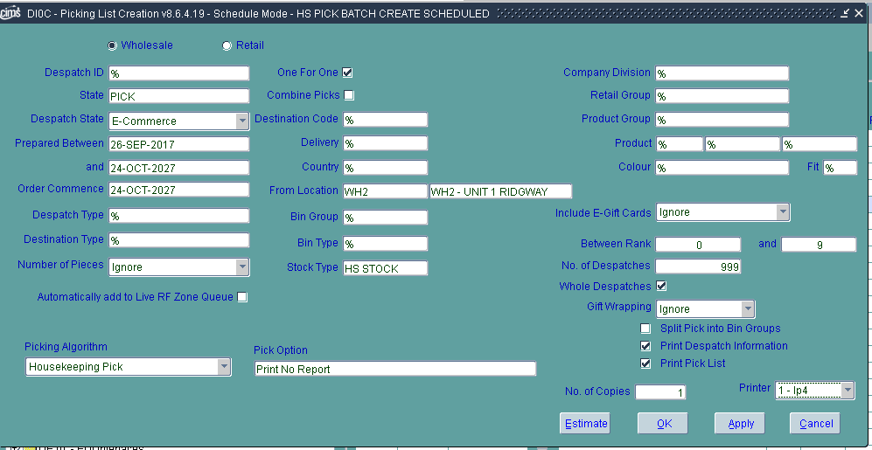

'GAR-CUST-STOCK' '90004' '%' 'W' 'E' '26-SEP-2017' '24-OCT-2027' '%' '%' '%' '%' '%' '%' '%' '%' '%' '%' '%' '%' '%' '%' '%' 'H' 'E010' '99' 'lp4' '1' 'Y' '999' '0' '9' 'N' '24-OCT-2027' 'Y' 'I' 'Y' 'N' 'I' 'I' 'N' 'Y'